**CSIS-3280-002_23334_201920**

**Web Based Scripting – Final Project (Web Service)**

Group Name: Brazil-Colombia connection

***Students: Jose Luiz Gomes, Luis Araujo, Pedro Rendon***

1) Description: The system will be able to register customers, items and place orders, provide totals for orders, and provide values in foreign currencies using WebService https://exchangeratesapi.io.

2) Class Diagram:

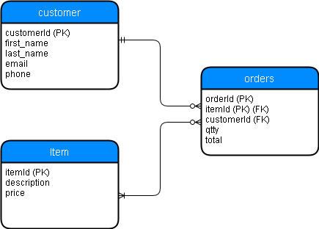

3) Meeting minutes: The group meetings happened 2 times within 30 minutes duration after class hours and online using WhatsApp as the project needed. Since the beginning of the project the group outlined what each one would be responsible to do and the due date for each requirement. In a weekly basis all the tasks where checked and each one uploaded the files in a One Drive repository for organization an accountability. The total time spent in meetings (online and in-person) was approximately 2.5 hours.

4) Project Schedule:

|  |  |
| --- | --- |
| **WHAT TO DO?** | **WHO?** |
| 1. Project submitted and named properly with all assets to Blackboard by Team Leader, file is named according to the naming convention. (**1 points)**   **DUE – IS AS FROM START TO END** | ALL |
| 1. Project Proposal, Class Diagram, Meeting Minutes, installation manual all completed with relevant details. **(3 points)**   **DUE (6th Aug)** | PEDRO, LUIS |
| 1. User Manual – Concise, to the point, graphical, labeled properly, Class Diagram accurate including all properties and cardinality. (**3 points)**   **DUE (5th Aug)** | PEDRO, LUIS |
| 1. Statistics are coded using SQL queries and displayed, PDO used and errors are captured and logged. The user must be given positive confirmation of a CRUD operation. (**3 points)**   **DUE (3th Aug)** | LUIS, JOSE |
| 1. All input validated according to the expected input, the user must be prompted for corrections and stack traces must be logged to a file. (**3 points)**   **DUE (30th July)** | LUIS, JOSE |
| 1. HTML Forms coded properly (framework can be used) layout is efficient and easy to use and controls are intuitive and easy to use. (**3 points)**   **DUE (30th July)** | PEDRO |
| 1. Good program structure is used, all functions are commented, and comments are used where applicable. Naming conventions are followed. (**5 points)**   **DUE (4th Aug)** | ALL |
| 1. Web Service integrated with error handling **(3 points)**   **DUE (30th July)** | ALL |

5) User Manual

**Prerequisites:**

* To have Wamp Server services currently installed and working.
* Must place all the project files under a Wamp Server Alias Path.
* **Loading Database**

In order to run the app for the first time, databases need to be set up. To do that, follow the next steps:

* + - On the project folder browser: open CMD (Command Prompt), type and run: “type CSIS3280.sql |mysql –u root –p”
    - If first step is successfully completed, then, type and run “type CSIS3280-Data.sql |mysql –u root –p”.
    - If first step is not successfully completed, try the following:
      * On the project folder browser: open CMD (Command Prompt), type and run: “mysql –u root –p”.
      * On Password request: Leave blank and press “Enter” key.
      * When MySQL monitor is ready, Copy and paste both SQL scripts from CSIS3280.sql and CSIS3280-Data.sql files.
      * If database is loaded successfully it may be check by: “use csis3280bcc” command and “show tables” command.

1. **Customers list Page**
   1. **How to search Customers by email.**

On the navigation bar, type the customer email that you want to search and click on the  button.

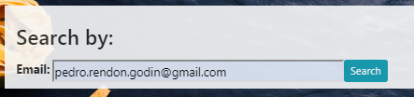

If customer is already in the database, then, it should appear on the customer list.

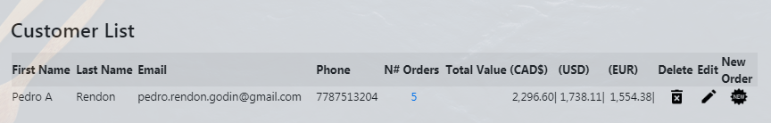

* 1. **How to add a new Customer**

On the main page, Scroll down the window until you find “Add Customer” Section. Fill the blanks with customer information as requested and then click on the  button.

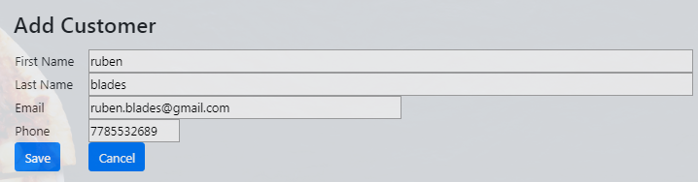

* 1. **How to edit existing Customer’s info.**

On the “customer list” section, look for the customer you want to edit. You might use the search navigation bar to filter your search. Once you find it, click on the C:\Users\user\Desktop\Douglas\PHP Web Based Scripting\Project\CodeV12\Project\inc\img\icons8-edit-24.png edit button.

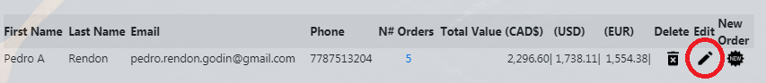

Current customer information will be loaded in to “add Customer” section which now will be known as “Edit Customer” Section. Fill in the information that you want to edit and then click on the  Button.

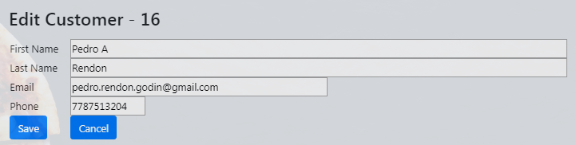

* 1. **How to delete an existing Customer.**

On the “customer list” section, look for the customer you want to delete. You might use the search navigation bar to filter your search. Once you find it, click on theC:\Users\user\Desktop\Douglas\PHP Web Based Scripting\Project\CodeV12\Project\inc\img\icons8-delete-bin-24.pngdelete button.

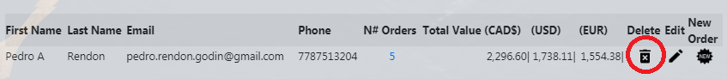

* 1. **How to get to the new customer order page.**

On the “customer list” section, look for the customer you want to add a new order. You might use the search navigation bar to filter your search. Once you find it, click on the C:\Users\user\Desktop\Douglas\PHP Web Based Scripting\Project\CodeV12\Project\inc\img\icons8-new-24.png new order button.



* 1. **How to review currently created customer orders.**

On the “customer list” section, look for the customer you want to review orders. You might use the search navigation bar to filter your search. Once you find it, click on the **N# Orders** button.

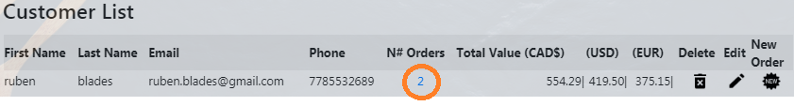

1. **Item List Page**
   1. **How to search existing items from the Item List.**

Use this search navigation bar when you are looking for a particular item that you want to add to the current customer order. Type the item description and click on the  button to filter item list with the description provided.

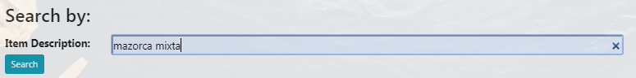

* 1. **How to create a new item for the Item list.**

On the item list page, Scroll down the window until you find “Add Item” Section. Fill the blanks with item information as requested and then click on the  button. Note prices must be provided in CAD.

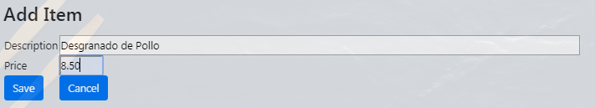

* 1. **How to edit existing items from the Item List.**

On the “Customer Name - Item list” section look for the item you want to edit. You might use the search navigation bar to filter your search. Once you find it, click on the C:\Users\user\Desktop\Douglas\PHP Web Based Scripting\Project\CodeV12\Project\inc\img\icons8-edit-24.png edit button.

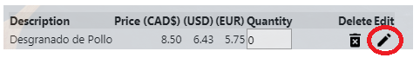

Current item information will be loaded in to “Add Item” section which now will be known as “Edit Item” Section. Fill in the information that you want to edit and then click on the  button.

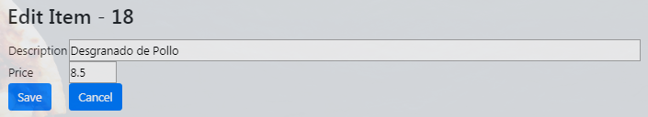

Note this information will be save on the Item table of the general database so the information will be uploaded an available for all customers.

* 1. **How to delete existing items from the Item List.**

On the “Customer Name - Item list” section look for the item you want to delete. You might use the search navigation bar to filter your search. Once you find it, click on the delete C:\Users\user\Desktop\Douglas\PHP Web Based Scripting\Project\CodeV12\Project\inc\img\icons8-delete-bin-24.png button.



* 1. **How to add a new order for a Customer.**

On the “Customer Name - Item list” section look for the all the items you want to add. Type an integer number for the quantity of each item that you want to add to the order. Once you have selected all the items, click on the  button. An action message will confirm the order was successfully created.

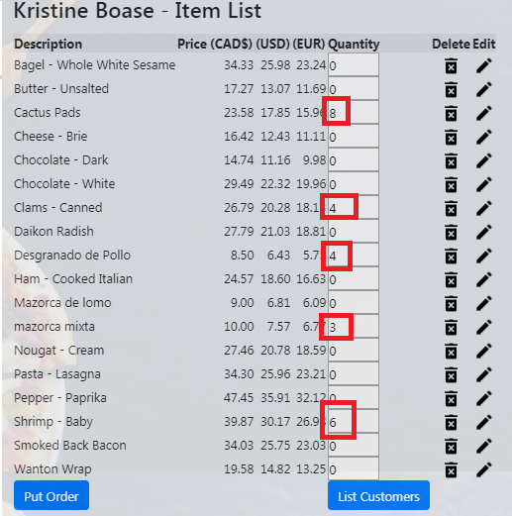



1. **Orders List Page**
   1. **How to search by Order Number or Item Description.**

Use this search navigation bar when looking for or filtering a particular order or item from any customer order. Type the order number or the item description and click on the  button to filter item list with the description or order # provided.

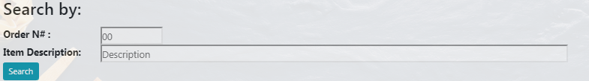

* 1. **How to delete a Customer Order.**

On the “Customer Name – Order List” section look for the item you want to delete. You might use the search navigation bar to filter your search. Once you find it, click on the delete C:\Users\user\Desktop\Douglas\PHP Web Based Scripting\Project\CodeV12\Project\inc\img\icons8-delete-bin-24.png button to delete any item from the order. To delete a complete order, you must delete item by item from a particular order #.

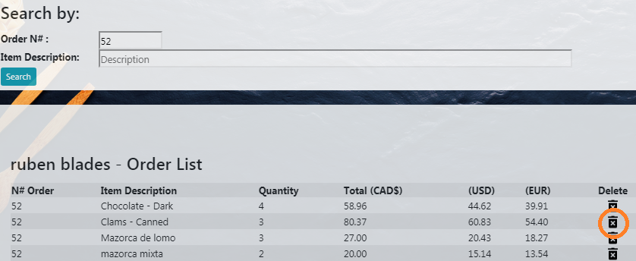

* 1. **How to add a new order for the current customer being reviewed.**

On the “Customer Name – Order List” section, click on the  button. This action will prompt item list page for the current customer.

**REFERENCES**

Webservice

<https://exchangeratesapi.io>

Class Diagrams

<https://www.lucidchart.com/pages/uml-class-diagram>

RESTful Web Service

<https://phppot.com/php/php-restful-web-service/>

Misc information

<https://www.w3schools.com/>

<https://www.php.net/>

Background image taken from:

<https://colorlib.com/wp/template/foodfun/>

Sklar, D. (2016). *Learning PHP: A gentle introduction to the Webs most popular language*. Beijing: OReilly.